Week 5: Opening multiple tabs for data exploration

- Open the Dashboard Challenge survey.

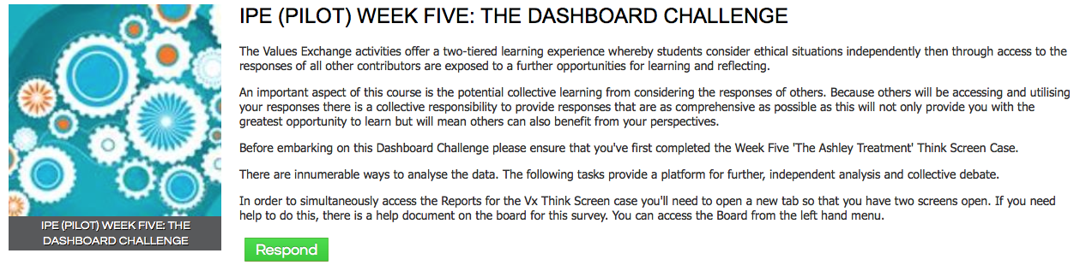

- Open a new tab from the option on your taskbar. Enter the url for the course: www.interprofessional.vxcommunity.com to open a new version of the site. In this window/tab locate and open The Ashley Treatment Case.
Ensure you’ve completed the Case then access the Reports Menu.

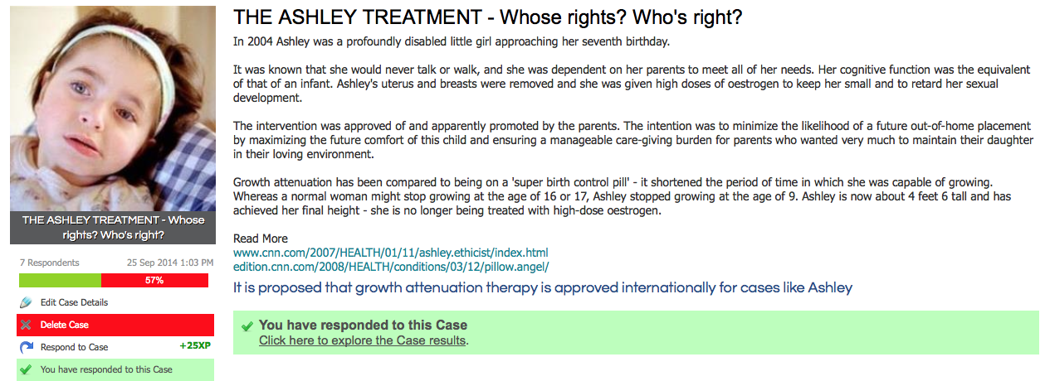

- The various reports described in the Dashboard Challenge are located along the top of the Reports Menu.
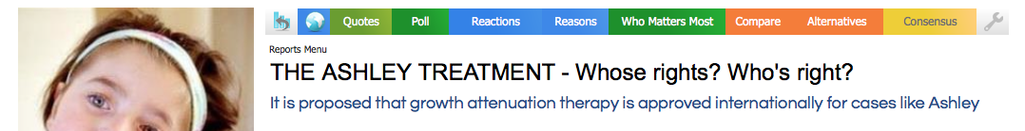

- For each report open new tab/window (by right clicking) on the coloured Report menu tabs.

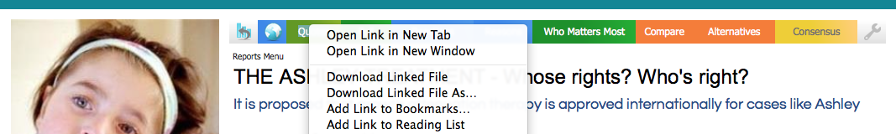

- Repeat for other reports you wish to simultaneously explore. You’ll end up with a task bar containing the Dashboard Challenge, The Ashley Treatment Case plus a page for each of your reports.

